 | SAKR MANNING AGENCY  FOR RECRUITING EGYPTIAN LABOR ABROAD | Issue Date | 15.05.2022
 |  | Revision Date | 01.02.2024
 | Crewing Management Manual  Seafarer Employment Application | Revision | 1.3
 |  | Page | 4

Application For Position as | OILER
Register Code. | ER-3.019
Other Position (If Any) | ------
Register Date | 20-11-2022
Last up Date Data
Expected Salary / Available Date | 1200 USD / 18/02/2025
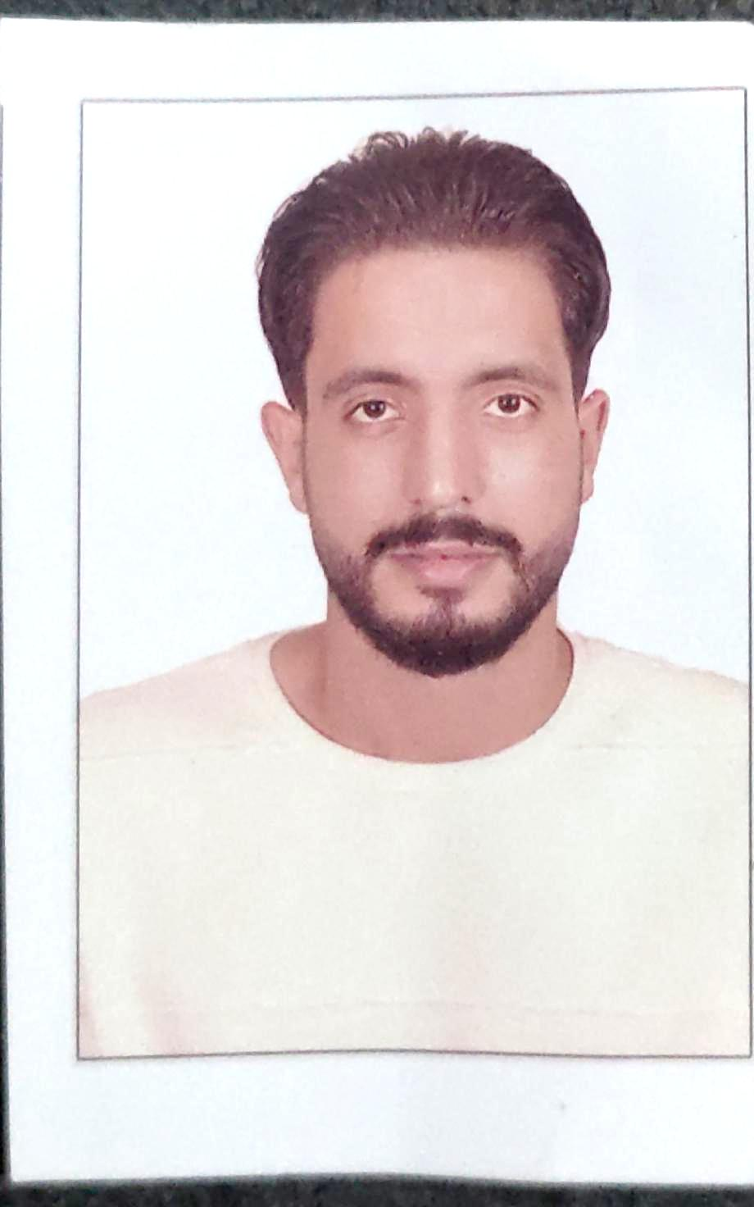

1. PERSONAL DETAILS
Full Name | ALAA AHMED MOHAMMED ATTAALLA
Date Of Birth | 01/02/1999 |  |  |  |  |  | Marital Status |  |  |  |  |  | Single |  |  |  |  |  | Married
Nationality | EGYPTIAN |  |  |  |  |  | Height (Cm) |  |  |  |  |  | 190 |  |  |  | Weight (Kg) |  |  |  |  | 80
Place Of Birth | KAFR EL SHEIKH |  |  |  |  |  | Overall Size |  |  |  |  |  | XL |  |  |  | Shirt Size |  |  |  |  | XL
Nearest Port | ALEXANDRIA |  |  |  |  |  | Trouser Size |  |  |  |  |  | 36 |  |  |  | Shoes Size |  |  |  |  | 45
2. EDUCATION
College / School | AAST
Marline Test | Issued Date |  |  |  | Result % |  |  | Issued By (Authority) |  |  |  |  |  |  |  | Issued At
English Language | Fluent |  |  |  |  | Good |  |  |  |  |  | Average |  |  |  | Poor
ARABIC Language  ( ) | Fluent |  |  |  |  | Good |  |  |  |  |  | Average |  |  |  | Poor
3. CONTACT DETAILS
Home Address / City | MENYET ELMORSHED / MOTOBUS / KAFER EL SHEIKH
E-Mail |  |  |  |  |  |  | Mobile / Tel |  |  | 00201013746991 |  |  |  |  |  |  |  | 00201200311132

4. TRAVEL DOCUMENTS
Type | Document No. |  |  | ISS. Date |  |  | Exp. Date |  |  |  | ISS. By (Authority) |  |  |  |  |  |  |  | Place of Issue
Passport | A35401050 |  |  | 12/10/2023 |  |  | 11/10/2030 |  |  |  | Egyptian Authority |  |  |  |  |  |  |  | Alex.
Seaman Book | S00024966 |  |  | 04/09/20222 |  |  | 28/08/2027 |  |  |  | EAMS |  |  |  |  |  |  |  | Alex.
Other Seaman Book

5. PROFESSIONAL QUALIFICATION / CERTIFICATE OF COMPETENCY
Certificate Name |  |  | Number | Issue Date |  |  |  |  | Expiry Date |  |  |  |  | Issued By |  |  |  |  |  |  | Issued At
COC ( Rank) ………….. |  |  | N/A |  |  |  |  |  |  |  |  |  |  | EAMS |  |  |  |  |  |  | Alex.
GOC |  |  | N/A |  |  |  |  |  |  |  |  |  |  | NTRA |  |  |  |  |  |  | Cairo
6. NEXT OF KIN / EMERGENCY CONTACT
Full Name |  | MOHAMED AHMED MOHAMED |  |  |  |  | Relationship |  |  |  |  | BROTHER
Address / Country |  | MENYET ELMORSHED / MOTOBUS / KAFER EL SHEIKH
Tel. No./ Mobile |  | 0020472696487/00201065233585 |  |  |  |  | Email |  |  |  |  | amir3talla@gmail.com
7. HEALTH CERTIFICATES & VACCINATIONS
Flag State |  | Number |  |  | Issue Date |  |  |  | Expiry Date |  |  |  |  |  | Issued By |  |  |  |  | Issued At
International Medical |  | 40312 |  |  | 10/02/2024 |  |  |  | 09/02/2026 |  |  |  |  |  | EAMS |  |  |  |  | Alex.
Yellow Fever |  |  |  |  | 01/11/2022 |  |  |  | XXXXXXX |  |  |  |  |  | Ministry of Health
Cholera |  |  |  |  |  |  |  |  |  |  |  |  |  |  | Ministry of Health
Covid-19 |  | Vaccination Name |  |  | First Dose |  |  |  | Second Dose |  |  |  |  |  | (Other Does or Remarks)
 |  | JOHNSON |  |  | 02/11/2021

8. MARINE COURSES
Course Name | Number | Issue Date | Expiry Date | Issued By / At
Personal Survival Techniques | 29748/22/EG | 05/10/2022 | 23/09/2027 | AAST
Proficiency In Personal Survival Techniques | N/A
Fire Prevention and Fire Fighting | 29748/22/EG | 05/10/2022 | 23/09/2027 | AAST
Advanced Fire Prevention and Fire Fighting | N/A
Elementary First Aid | 29748/22/EG | 05/10/2022 | 23/09/2027 | AAST
Medical Care Studies | N/A
Personal Safety and Social Responsibilities | 29748/22/EG | 05/10/2022 | 23/09/2027 | AAST
Proficiency Of Security Awareness Training Seafarers | 30669/22/EG | 11/10/2022 | 09/10/2027 | AAST
Proficiency as a ship Security officer ( PSSO ) | N/A
Proficiency In Survival Craft & Rescue Boats | 40289/22/EG | 27/12/2022 | 21/12/2027 | AAST
G.M.D.S.S | N/A
Communications | N/A
Advanced Communications | N/A
ECDIS Advanced Simulator (Management Level) | N/A
ECDIS Simulator (Operation Level) | N/A
Prevention and Combating of Marine Pollution | N/A
Radar & ARPA Simulator and Search &rescue  ARPA Simulator and Search | N/A
Marine Radar and automatic Radar Plotting | N/A
Bridge resource Management (B.R.M) | N/A
Engine resource Management (E.R.M) | N/A
Navigational Watch keeping | N/A
Proficiency for Rating forming part of Navigational watch (II/4) | N/A |  |  | EAMS / Alex.
High voltage training – operation of ship (1000 Volt and More) | N/A
Passenger Safety Cargo Safety and Hull integrity | N/A
Crowd Management Training | N/A
Crisis Management and Human Behavior Training | N/A
Safety training for Personal Prov. Direct Passengers | N/A
Practical Ability to Prepare Meals and (MLC 2006) | N/A
Personal Hygiene and Envir. Protection (MLC 2006) | N/A
Safety and Health in the Provision Meals (MLC 2006) | N/A
Food Storage and inventory Control (MLC 2006) | N/A
Ships Cook Certificate (MLC 2006) | N/A |  |  | EAMS / Alex.
Abel Seafarer Deck | N/A
Proficiency for Abel Seafarer Deck ( II/5 ) | N/A |  |  | EAMS / Alex.
Engineering Watch keeping | 30389/22/EG | 11/10/2022 | XXXXX | EAMS / Alex.
Proficiency for Rating forming part of a watch in engine room | N/A
Abel Seafarer Engine | N/A
Proficiency for Abel Seafarer Engine ( III/5 ) | N/A |  |  | EAMS / Alex.
Electro Technical Rating | N/A
Proficiency for Electro Technical rating ( III/7 ) | N/A |  |  | EAMS / Alex.
D.p. induction/ d.p. advanced | N/A
D.p. operator (unlimited) | N/A
Others

 |  | 9 - COMPLETE SEA – SERVICE DETAILS
Name: |  | ALAA AHMED MOHAMED ATTA-ALLA |  |  |  |  | Rank: | OILER |  | Register Code:
Company Name |  |  | Rank | Vessel Name/IMO Number | Flag | Signed On |  | Signed Off |  | Period | Vessel Type |  | D.W.T./ G.R.T |  | Engine Type | BH/ KW |  | Reason for Sign off
SALEM AL MAKRANI CARGO CO |  |  | OILER | AL SALMY 5 / 8118839 | U.A.E | 10/08/2021 |  | 05/08/2022 |  | 12M | RO-RO / CARGO |  | 7200 / 12530 |  | MAK 12M 453 AK | 3600 KW |  | END OF CONTRACT
JK LTD |  |  | OILER | ANKA / 9365415 | MONGOLIA | 21/01/2023 |  | 27/09/2023 |  | 08M & 06D | GENERAL CARGO |  | 5104 / 3043 |  | DIESEL G8300ZC18B, NINGBO POWER, | 1756 KW |  | END OF CONTRACT
JK LTD |  |  | OILER | ANKA / 9365415 | MONGOLIA | 18/10/2023 |  | 28/08/2024 |  | 10M & 10D | GENERAL CARGO |  | 5104 / 3043 |  | DIESEL G8300ZC18B, NINGBO POWER, | 1756 KW |  | END OF CONTRACT
10. REFERENCES
No | Company / Management / Country |  |  |  |  |  | Position |  | Name |  |  | TEL |  | EMAIL
01 | SALEM AL MAKRANI CARGO CO. / U.A.E |  |  |  |  |  | D.P.A |  | CAPT/ NIZAR KADOURA |  |  | +971505596264 |  | almakrani@emirates.net.ae
11. DECLARATION
Please answer the following questions:
- Did you suffer, or presently suffer from, any disease likely to render you unfit for services at sea or likely to endanger the health of other persons on board?  If yes, please provide details _______________________________________________  ______________________________________________________________________ | YES NO
- Did you suffer any accident, which rendered you temporary and/or partially disabled? | YES NO
- Did you ever undergo psychiatric treatment | YES NO
- Are you addicted to alcohol or drugs of any kind? | YES NO
I hereby declare that the above facts and information are true and accurate. I further consent to the holding and processing by (i) the owners of any vessel on which I may be assigned from time to time and (ii) the Managers and any direct or indirect parent or subsidiary or associated or affiliated company of the Managers (together referred to as "the Companies") for the purposes of my employment, of personal data about me contained herein, or provided to any of the Companies at a later date, including with respect to personal and pensions administration, employee management and as required to comply with any laws, regulations or contracts applicable to any of the Companies or their businesses. I understand that this data will be stored in the Managers’ database for the purposes of my current or future employment arranged by the Managers. Further, I confirm that the above may involve the transfer of my personal data within the Managers’ organization.
Place_______ALEXANDRIA_____________ Date _______17/02/2025____________ Signature __________ALAA AHMED MOHAMED_________
12.For Office Use Only
Initial assessment of applicant for further recruitment
Comments

Responsible person

Name / Signature _______________________________________________ Date ________________________________

